Email Subject Line: SIGN THE PETITION: ALL our kids healthy, fed & housed
Email Body Text:
Dear [FIRST NAME],
We’re partnering with the End Child Poverty California movement to fight for change in 2020. Help us build momentum by signing the petition. Our goal is to make sure our leaders know that ALL California children deserve to be healthy, fed & housed.
Why now? California has a groundbreaking roadmap to end extreme child poverty: the End Child Poverty Plan. Last year, the movement achieved big wins to support the plan—doubling California’s Earned Income Tax Credit for workers making about $32,000 or less, creating a Young Child Tax Credit, and so much more. (Find out more.)
In California, we’ve saved lives by passing the country’s strictest gun-safety laws. We’ve fought climate change by implementing ambitious clean-air rules. We’re pioneers. And we know that, in our fight to end extreme child poverty, we can make California a model for the nation.
Sign the petition to tell elected officials: Let’s make 2020 the year we pass the End Child Poverty Plan in FULL.
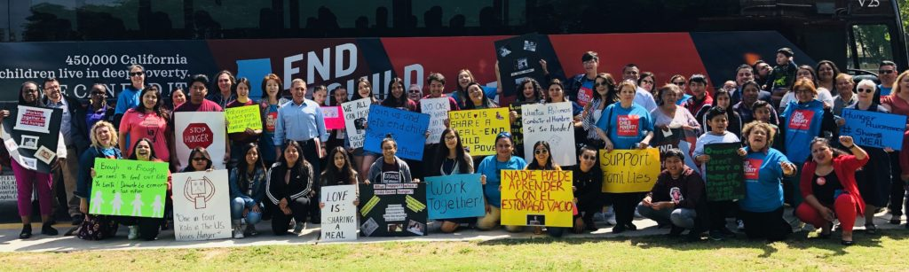Californians come together at the End Child Poverty Plan rally in Weedpatch, Cal. – May 2019
Families are working incredibly hard. But right now, too many parents have to choose between paying rent, putting food on the table or paying for transportation to work. They’re losing jobs because they don’t have the sick leave to take care of their children or the child care to cover their schedules.
Families know what they need to become stable. Let’s make sure they get it.
Sign the petition: Fully enact the End Child Poverty Plan in 2020. Together, we can end extreme poverty for 450,000 California kids and cut the overall child poverty rate in half!
California parents are striving to build a bright future for their kids, and your signature is a powerful symbol that you’re with us as we work together to #EndChildPovertyCA.
Together for our families,
[NAME, TITLE, ORGANIZATION]

